Focused Guest Experience Audit

Introduction
Our consultancy delivers in-depth, unbiased guest experience audits designed to elevate your hotel’s performance. We can assess every department—from booking and arrival to dining, recreation, and departure. Our process pinpoints subtle service or facility issues that, if left unchecked, can erode overall guest satisfaction. The result is clear, actionable recommendations that enhance service consistency, reduce negative reviews, and grow loyalty.
Key Performance Metrics
Besides traditional stars, many boutique accommodations track:
• Guest review scores (Google Reviews, TripAdvisor, Booking.com, etc.)
• KPIs such as Average Daily Rate (ADR), RevPAR, and guest satisfaction.
• Reputation via from new and traditional media. Bloggers and Influencers.

The Expectation Pyramid: Understanding Guest Psychology

The Premise
Guests arrive full of excitement and high expectations—the “peak of the pyramid.” Every small disappointment, or “1% annoyance,” causes the pyramid to erode, moving guests further from delight and closer to disappointment. Our mission, alongside yours, is to prevent this erosion and keep guests at their emotional peak throughout their stay.

Stages of the Pyramid
The Pinnacle of Anticipation (Pre-Arrival & Arrival)
- Guests arrive with hopes and idealised expectations.
- First impressions are vital; a friendly greeting and smooth check-in are essential.
The Plateau of Comfort (Early Stay)
- Positive experiences—spotless rooms, attentive staff—reinforce satisfaction.
- Small cracks (e.g., no fresh juice or missed amenities) quietly undermine trust.
The Erosion Zone (Mid-Stay)
- Inconsistencies and minor faults accumulate, causing a visible dip in satisfaction (e.g., malfunctioning air conditioning, confusing TV remotes).
- At this stage, guests become more sensitive to further issues.
Exit Judgment (Check-Out & Departure)
- Final interactions redefine the entire stay.
- A warm farewell can elevate the experience; a cold, rushed checkout can erase goodwill.
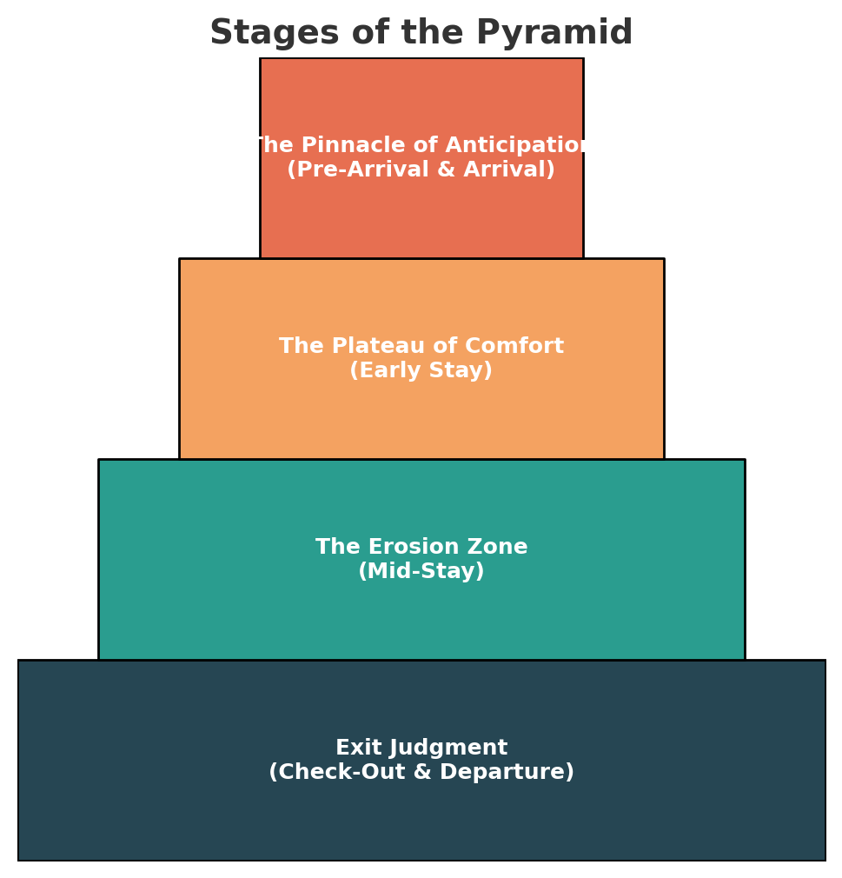

Guest Journey Map with Emotional Peaks
A timeline mapping the guest’s emotional highs and lows across their journey (booking through to check-out), clarifying where delight or dissatisfaction peaks—revealing how small early failures can resonate throughout their stay.

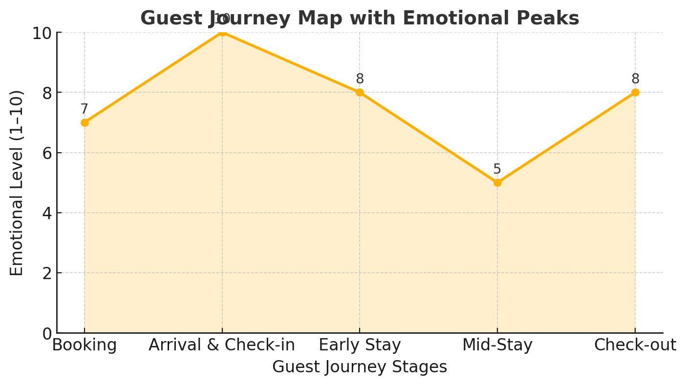

Service Audit:

Units of measurement Status:

Minor: Guest annoyances, observations, small grievances.
Examples. Wear on high traffic areas, worn and unmaintained furntiture, room service dishes left in corridors, leaf litter on pathways, too bright bedside lamps, neutral spirit in cocktail preparation, no ironing board access, out of date common space playlists, poor coffee service, dirty bathroom / linen/ floors, dusty furniture or hair in the shower. low quality or missing amenities, water pressure and drainage, lack of charging outlets, minimal bathroom bench space, challenging TV remotes, lack of local information, no suitcase storage
Major: Conditions directly impacting guest comfort or safety.
Examples. Faulty or noisy in room air conditioning, lack of consideration of guest dietary requirements, shade free pools (tropics) including over chlorination, slippery / uneven walkways, lack of fans / heating in dining areas and common spaces, bugs and pests, external noise. uncomfortable pillow/mattress, no hot water, misleading marketing collateral.
Critical: Impacting on guest ability to be accommodated by the site.
Examples. Booking platform failure, direct website offline, site power outage, lack of clear instructions from reception. Wifi speed and outages

Overall Physical Site Condition Checklist example

Area | Key Focus areas | Status
Front of House / Lobby | Flooring, overall cleanliness  Poolroom common space excellent  Reception furniture wear  First impressions staff greeting friendly and engaging, informal, helpful | Conforms  Conforms  Minor
Bedrooms and Housekeeping | Room presentation excellent  Many ‘trinkets’ in room creating clutter  Floorcoverings excellent  Bed comfort and quality of bed clothes excellent  Turn down service a little too early  Unexplained Rumble in air-conditioned | Conforms  Minor  Conforms  Conforms  Minor  Major

Detailed areas of audit focus to select from

Front of House / Lobby
- Staff greeting, professionalism, and first impressions
- Efficiency of check-in/check-out
- Cleanliness, ambiance, lighting, and scent
- Concierge service responsiveness

Guest Rooms
- Room and bathroom cleanliness, bed and pillow comfort
- Furniture and fixture condition, noise, and maintenance
- Technology: TV, Wi-Fi, charging stations
- Ambient and task lighting

Dining & Bar Areas
- Food and beverage quality, freshness, and presentation
- Staff attentiveness and product knowledge
- Cleanliness of tables, cutlery, and service areas
- Breakfast and buffet checks (e.g., juice temperature and freshness)

Recreation & Spa Facilities
- Cleanliness of gyms, pools, and spas
- Availability of towels, amenities, and water
- Staff interactions and efficiency
- Safety measures and equipment condition

Housekeeping & Maintenance
- Punctuality and thoroughness of room cleaning and turndown
- Detail attention: dust, linens, flooring, electronics
- Responsiveness to guest requests

Outdoor & Landscaping
- Garden and pathway maintenance
- External cleanliness (windows/glass) and lighting

Restrooms (Public Areas)
- Stock of supplies
- Fixtures and mirror condition

Additional touchpoints
- Staff local knowledge ( cultural, weather )
- Storytelling and informal guest engagement

Example report Lobby and Guest rooms only

Hotel Name: Oceanview Grand Resort
Audit Date: July 10, 2025
Auditor: Emma Clark

1. Front of House / Lobby
- Upon arrival at 2:10 PM, guests were promptly greeted by a uniformed staff member with a warm welcome and clear directions to the check-in counter.
- Check-in was completed efficiently within four minutes. The staff maintained a professional demeanor, confirmed the reservation, and offered information about available amenities.
- The lobby presented a fresh scent, ambient lighting, and was spotless. Seating and decorative elements were well-maintained, with no visible litter or dust. A little wear present on the chair arms.
- Concierge staff solicited provided a quick, helpful recommendation for local dining, responding within two minutes.

2. Guest Rooms
- Room 516 was inspected shortly after guest entry. The space and bathroom were immaculately clean, with crisp linens and dust-free surfaces.
- Bed and pillows offered excellent comfort, with no noticeable wear.
- All furniture and fixtures were in good condition; there were no maintenance issues or unsettling noise from adjacent rooms or corridors.
- The smart TV, Wi-Fi, and USB charging stations were functional and easy to use.
- Both ambient (overhead) and task (desk/bed) lighting were bright and adjustable, with bulbs working.

